Please complete the below details and return back to us: sales@palatinepaints.co.uk

From this information we are able to confirm that you have purchased sufficient product to achieve the required fire rating level/standard you wish to achieve.

Customer Name

Customer Contact Details

Site Address

Fire Protection Rating Required
30mins |  | 60mins |  | 90mins |  | 120mins
Is the steel
Primed |  | Visible |  | Dry Internal |  | Damp Internal |  | External

Are the Roof and Walls Erected
Details of Steel
Section Type/Shape  Serial Size and  Mass * | No. Sides  To be  Painted  * | Vertical Post(V)  Horizontal Floor Beam  Rafter (H) | Supporting Floor  Y/N | Web Depth  Mm * | Flange Width  Mm * | Either  Mass per Kg  (If known) | Or  Thickness  Of Flange  mm | Total  Length
* See Sheet 2

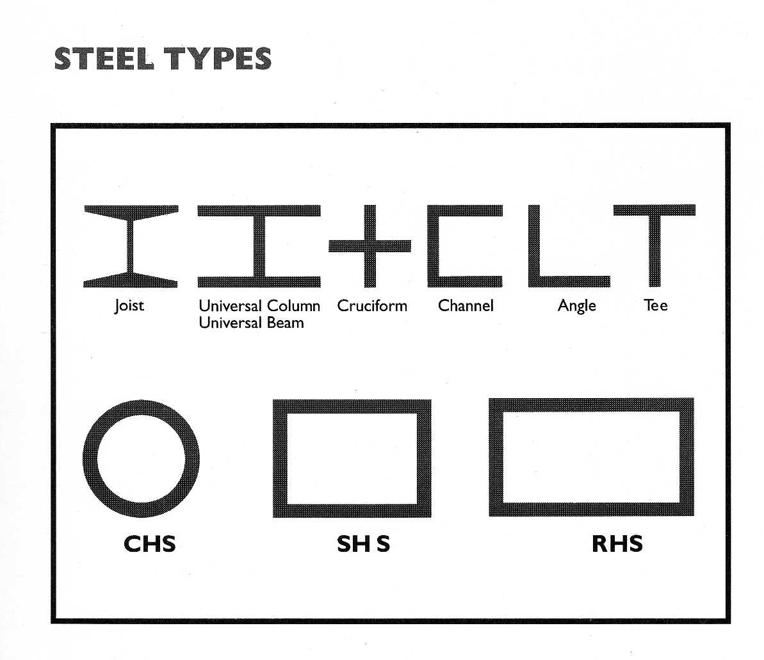
Serial Size and Mass e.g. UC 203x203x46
STEEL TERMINOLOGY
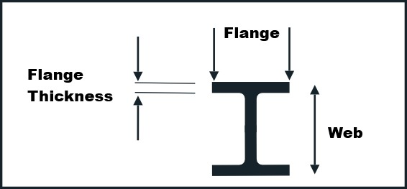
SIDES EXPOSED
